**SE 102.3 – Web Based Application Development**

**Tutorial**

1. Write down the HTML codes required to generate the following outputs.

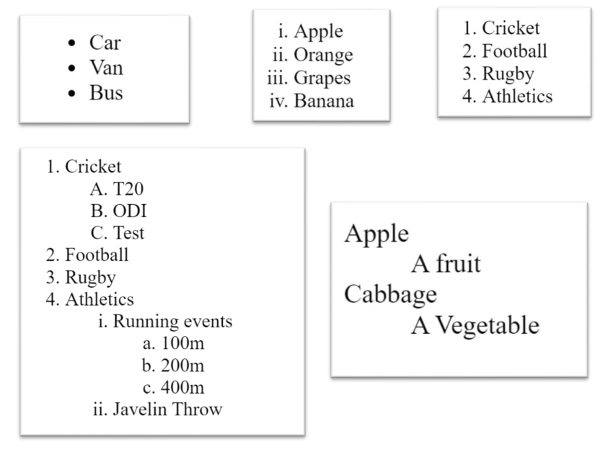



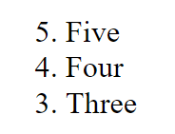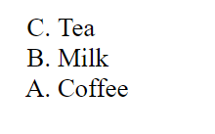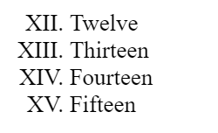

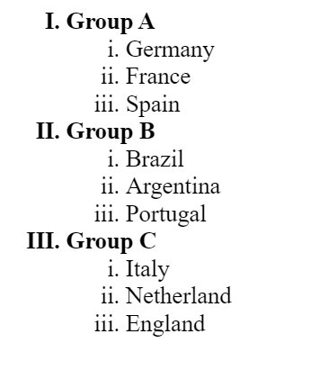

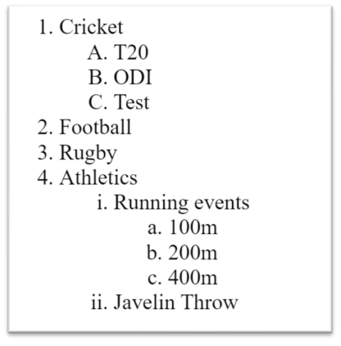

**Answers**

<html>

<head>

<title>Tutorial</title>

</head>

<body>

<ul>

<li>Car</li>

<li>Van</li>

<li>Bus</li>

</ul>

<ol type="i" >

<li>Apple</li>

<li>Orange</li>

<li>Grapes</li>

<li>Banana</li>

</ol>

<ol type="1" >

<li>Cricket</li>

<li>Football</li>

<li>Rugby</li>

<li>Athletics</li>

</ol>

<ul style="list-style-type:none;" >

<li>Apple</li>

<ul style="list-style-type:none;" >

<li>A fruit</li>

</ul>

<li>Cabbage</li>

<ul style="list-style-type:none;" >

<li>A Vegetable</li>

</ul>

</ul>

<ol type="I" start="12" >

<li>Twelve</li>

<li>Thirteen</li>

<li>Fourteen</li>

<li>Fifteen</li>

</ol>

<ol reversed type="A" >

<li>Tea</li>

<li>Milk</li>

<li>Coffee </li>

</ol>

<ol reversed type="1" start="5">

<li>Five</li>

<li>Four</li>

<li>Three </li>

</ol>

<ol type="1" >

<li>Cricket</li>

<ol type="A" >

<li>T20</li>

<li>ODI</li>

<li>Test</li>

</ol>

<li>Football</li>

<li>Rugby</li>

<li>Athletics</li>

<ol type="i" >

<li>Running events</li>

<ol type="a" >

<li>100m</li>

<li>200m</li>

<li>400m</li>

</ol>

<li>Javelin Throw</li>

</ol>

</ol>

</body>

</html>